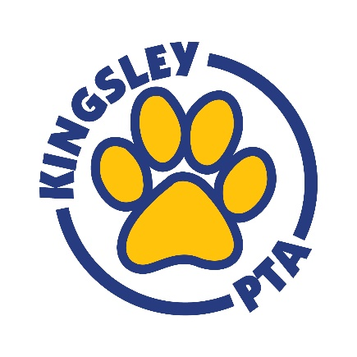
CALENDAR

OCTOBER 2019
10/08 General PTA Meeting @ Kingsley (3:00-4:00 PM)
10/11 Pizza Fun Lunch
10/14 NO SCHOOL (Columbus Day)
10/15 NO SCHOOL Parent-Teacher Conferences and Chipotle Benefit Night
10/16 Book Fair (Day 1)
10/17 Book Fair (Day 2)/Parent-Teacher Conferences
10/22 Picture Retakes
10/31 Halloween Parade/Parties
​

NOVEMBER 2019
11/05 General PTA Meeting @ Kingsley (7:00-8:00 PM)
11/08 Pizza Fun Lunch
11/13 Mojo’s Benefit Night
11/15 End of Trimester
11/22 Full Fun Lunch
11/25-29 Thanksgiving Break

DECEMBER 2019
12/02 NO SCHOOL
New! 12/03 Transportation and Safety Meeting featuring DG58 BOE Superintendent
Dr. Kevin Russell and Mayor Bob Barnett @ Kingsley (7-8pm)
12/07 Pancake Breakfast & Holiday Shop
12/11-12/15 Cozzi Corner Benefit Days
12/13 Pizza Fun Lunch
12/20 PTA Sponsored Holiday Treat
12/23- 1/03 Holiday Break

JANUARY 2019
01/06 School Resumes
01/07 General PTA Meeting @ Kingsley (7:00-8:00 PM)
01/17 Pizza Fun Lunch
01/20 NO SCHOOL(Martin Luther King, Jr. Day)
01/25 Science Fair
01/28 & 1/30 Parent-Teacher Conferences
01/31 Full Fun Lunch
​
** PLEASE NOTE MONDAY DISMISSAL TIME IS NOW 2:00 PM **

